GlobalEdu Consultancy Website UI Clone

Front-End Development Project Report
Prepared By:
Nidhi Mangtani
Amrita Vishwa Vidyapeetham
Computer Science Engineering (CSE)

1. Project Overview
This project is a front-end website developed for a study abroad consultancy platform named GlobalEdu Consultancy. The website was designed by taking inspiration from modern consultancy websites and adapting the design into a simpler and beginner-friendly version.
The main aim of the project was to create a responsive and visually appealing website using HTML, CSS, and JavaScript without depending heavily on frameworks. The project focuses on creating a clean user interface, proper section structuring, responsive layouts, and smooth user interaction.
The website includes sections such as a landing page, services, destinations, testimonials, about section, and contact form. Attention was given to spacing, color combinations, typography, and responsiveness so the website feels modern while still being understandable for beginner-level developers.
This project also helped improve practical front-end development skills including responsive web design, layout creation, styling, and JavaScript-based interaction.

2. Key Features
• Responsive Navigation Bar
A fixed navigation bar was designed to provide smooth navigation across different sections of the website. The navbar remains visible while scrolling and adjusts properly on smaller screens for mobile responsiveness.
• Modern Hero Section
The landing section includes large headings, a consultancy-style layout, and a responsive image banner. A dark blue theme was used to give the website a professional consultancy appearance similar to modern education platforms.
• Responsive Service Cards
The services section displays important consultancy services such as university admissions, visa guidance, and IELTS coaching using responsive card layouts and hover effects.
• Destination Showcase Section
A dedicated section was created to showcase popular study destinations such as Canada, USA, UK, and Australia using country cards and flag images.
• Testimonial Section
A testimonial section was added to make the website feel more realistic and user-friendly. The section displays student feedback in a clean card-based layout.
• Contact Form with JavaScript Validation
The contact form uses JavaScript to handle form submission interactions and display alert messages after successful submission.
• Mobile Responsive Design
Media queries and flexible layouts were used to ensure that the website works properly across desktops, tablets, and mobile devices.

3. Technical Architecture
• HTML5
HTML5 was used to structure the content of the website including navigation bars, sections, forms, buttons, cards, and footer.
• CSS3
CSS3 was used for designing layouts, adding colors, spacing, hover effects, responsiveness, shadows, and typography styling.
Important CSS concepts used in the project include:
- Flexbox
- CSS Grid
- Media Queries
- Transitions
- Border Radius
- Box Shadows
• Vanilla JavaScript
JavaScript was used for:
- Form submission alerts
- Button interactions
- Event handling
- Basic DOM manipulation
The project avoids heavy frameworks and focuses on beginner-friendly front-end development concepts.
- Interactive User Interface Design

CODE -
<!DOCTYPE html>
<html lang="en">
<head>
<meta charset="UTF-8">
<meta name="viewport" content="width=device-width, initial-scale=1.0">
<title>GlobalEdu Consultancy</title>

<!-- Google Font -->
<link rel="preconnect" href="https://fonts.googleapis.com">
<link href="https://fonts.googleapis.com/css2?family=Poppins:wght@300;400;500;600;700&display=swap" rel="stylesheet">

<style>

*{
margin:0;
padding:0;
box-sizing:border-box;
}

body{
font-family:'Poppins',sans-serif;
background:white;
}

html{
scroll-behavior:smooth;
}

.container{
width:90%;
max-width:1200px;
margin:auto;
}

/* Navbar */

.custom-navbar{
background:#06142e;
padding:15px 0;
position:fixed;
width:100%;
top:0;
z-index:1000;
}

.navbar-content{
display:flex;
justify-content:space-between;
align-items:center;
}

.navbar-brand{
font-size:28px;
font-weight:700;
color:white;
text-decoration:none;
}

.nav-links{
display:flex;
list-style:none;
}

.nav-links li{
margin-left:20px;
}

.nav-links a{
color:white;
text-decoration:none;
font-size:16px;
}

/* Hero Section */

.hero-section{
background:#06142e;
padding-top:120px;
min-height:100vh;
display:flex;
align-items:center;
}

.hero-content{
display:flex;
align-items:center;
justify-content:space-between;
gap:50px;
}

.hero-left{
flex:1;
color:white;
}

.hero-right{
flex:1;
}

.hero-title{
font-size:58px;
font-weight:700;
line-height:1.2;
}

.hero-text{
color:#d4d4d4;
margin:25px 0;
font-size:18px;
}

.hero-btn{
padding:12px 30px;
border:none;
background:#0d6efd;
color:white;
border-radius:40px;
font-size:16px;
cursor:pointer;
}

.hero-image{
width:100%;
border-radius:25px;
height:500px;
object-fit:cover;
box-shadow:0 10px 25px rgba(0,0,0,0.2);
}

/* About */

.about-section{
padding:80px 0;
}

.about-content{
display:flex;
align-items:center;
gap:50px;
}

.about-left,
.about-right{
flex:1;
}

.about-image{
width:100%;
border-radius:25px;
box-shadow:0 5px 20px rgba(0,0,0,0.1);
}

.section-title{
font-size:38px;
font-weight:700;
margin-bottom:20px;
}

.about-btn{
margin-top:20px;
padding:12px 25px;
background:#0d6efd;
color:white;
border:none;
border-radius:30px;
cursor:pointer;
}

/* Services */

.services-section{
padding:80px 0;
}

.section-center{
text-align:center;
margin-bottom:50px;
}

.services-grid{
display:grid;
grid-template-columns:repeat(3,1fr);
gap:30px;
}

.service-card{
background:white;
padding:35px 25px;
border-radius:20px;
text-align:center;
box-shadow:0 5px 20px rgba(0,0,0,0.08);
transition:0.3s;
}

.service-card:hover{
transform:translateY(-8px);
}

.service-icon{
font-size:45px;
margin-bottom:20px;
}

/* Destinations */

.destination-section{
background:#f5f7fb;
padding:80px 0;
}

.destination-grid{
display:grid;
grid-template-columns:repeat(4,1fr);
gap:25px;
}

.destination-card{
background:white;
border-radius:18px;
padding:20px;
text-align:center;
box-shadow:0 5px 20px rgba(0,0,0,0.08);
transition:0.3s;
}

.destination-card:hover{
transform:translateY(-6px);
}

.country-img{
width:100%;
height:180px;
object-fit:cover;
border-radius:15px;
margin-bottom:15px;
}

/* Testimonials */

.testimonial-section{
padding:80px 0;
}

.testimonial-box{
background:#f5f7fb;
padding:40px;
border-radius:20px;
text-align:center;
max-width:700px;
margin:auto;
}

/* Contact */

.contact-section{
padding:80px 0;
}

.contact-box{
background:white;
padding:40px;
border-radius:20px;
box-shadow:0 5px 20px rgba(0,0,0,0.08);
max-width:800px;
margin:auto;
}

.form-row{
display:flex;
gap:20px;
}

.form-group{
margin-bottom:20px;
width:100%;
}

.form-control{
width:100%;
padding:14px;
border:1px solid #ccc;
border-radius:10px;
font-size:15px;
}

textarea{
resize:none;
}

.submit-btn{
width:100%;
padding:14px;
background:#0d6efd;
color:white;
border:none;
border-radius:10px;
cursor:pointer;
font-size:16px;
}

/* Footer */

footer{
background:#06142e;
color:white;
padding:40px 0;
text-align:center;
}

/* Responsive */

@media(max-width:992px){

.hero-content,
.about-content{
flex-direction:column;
}

.services-grid{
grid-template-columns:1fr;
}

.destination-grid{
grid-template-columns:1fr 1fr;
}
}

@media(max-width:768px){

.hero-title{
font-size:40px;
}

.section-title{
font-size:30px;
}

.hero-image{
height:350px;
}

.destination-grid{
grid-template-columns:1fr;
}

.nav-links{
display:none;
}

.form-row{
flex-direction:column;
}
}

</style>
</head>
<body>

<!-- Navbar -->

<nav class="custom-navbar">

<div class="container navbar-content">

<a href="#" class="navbar-brand">GlobalEdu</a>

<ul class="nav-links">

<li><a href="#home">Home</a></li>
<li><a href="#about">About</a></li>
<li><a href="#services">Services</a></li>
<li><a href="#destinations">Destinations</a></li>
<li><a href="#contact">Contact</a></li>

</ul>

</div>

</nav>

<!-- Hero -->

<section id="home" class="hero-section">

<div class="container hero-content">

<div class="hero-left">

<h1 class="hero-title">
Start Your Study Abroad Journey Today
</h1>

<p class="hero-text">
Get expert guidance for university admissions, visas and scholarships for top international destinations.
</p>

<button class="hero-btn" onclick="showMessage()">
Book Free Counselling
</button>

</div>

<div class="hero-right">

<img
src="https://images.unsplash.com/photo-1523240795612-9a054b0db644?q=80&w=1200&auto=format&fit=crop"
class="hero-image">

</div>

</div>

</section>

<!-- About -->

<section id="about" class="about-section">

<div class="container about-content">

<div class="about-left">

<img
src="https://images.unsplash.com/photo-1522202176988-66273c2fd55f?q=80&w=1200&auto=format&fit=crop"
class="about-image">

</div>

<div class="about-right">

<h2 class="section-title">
About Us
</h2>

<p>
We help students achieve their dream of studying abroad with expert counselling, university admissions, visa support and scholarship guidance.
</p>

<br>

<p>
Our team provides complete assistance throughout the entire admission journey.
</p>

<button class="about-btn">
Learn More
</button>

</div>

</div>

</section>

<!-- Services -->

<section id="services" class="services-section">

<div class="container">

<div class="section-center">

<h2 class="section-title">
Our Services
</h2>

<p>
Helping students at every step of the process.
</p>

</div>

<div class="services-grid">

<div class="service-card">

<div class="service-icon">🎓</div>

<h4>University Admissions</h4>

<p>
Get expert help for selecting universities and courses.
</p>

</div>

<div class="service-card">

<div class="service-icon">🛂</div>

<h4>Visa Guidance</h4>

<p>
Complete support for student visa applications and interviews.
</p>

</div>

<div class="service-card">

<div class="service-icon">📚</div>

<h4>IELTS Coaching</h4>

<p>
Professional coaching for IELTS and language exams.
</p>

</div>

</div>

</div>

</section>

<!-- Destinations -->

<section id="destinations" class="destination-section">

<div class="container">

<div class="section-center">

<h2 class="section-title">
Top Study Destinations
</h2>

</div>

<div class="destination-grid">

<div class="destination-card">

<img src="https://flagcdn.com/w320/ca.png" class="country-img">

<h5>Canada</h5>

</div>

<div class="destination-card">

<img src="https://flagcdn.com/w320/gb.png" class="country-img">

<h5>United Kingdom</h5>

</div>

<div class="destination-card">

<img src="https://flagcdn.com/w320/us.png" class="country-img">

<h5>USA</h5>

</div>

<div class="destination-card">

<img src="https://flagcdn.com/w320/au.png" class="country-img">

<h5>Australia</h5>

</div>

</div>

</div>

</section>

<!-- Testimonials -->

<section class="testimonial-section">

<div class="container">

<div class="section-center">

<h2 class="section-title">
Student Testimonials
</h2>

</div>

<div class="testimonial-box">

<p>
“The whole admission and visa process became very easy because of GlobalEdu Consultancy.”
</p>

<br>

<h5>
- Riya Patel
</h5>

</div>

</div>

</section>

<!-- Contact -->

<section id="contact" class="contact-section">

<div class="container">

<div class="contact-box">

<div class="section-center">

<h2 class="section-title">
Contact Us
</h2>

</div>

<form id="contactForm">

<div class="form-row">

<div class="form-group">

<input type="text" class="form-control" placeholder="Your Name" required>

</div>

<div class="form-group">

<input type="email" class="form-control" placeholder="Email Address" required>

</div>

</div>

<div class="form-group">

<input type="text" class="form-control" placeholder="Preferred Country">

</div>

<div class="form-group">

<textarea class="form-control" rows="5" placeholder="Your Message"></textarea>

</div>

<button class="submit-btn">
Submit Inquiry
</button>

</form>

</div>

</div>

</section>

<!-- Footer -->

<footer>

<div class="container">

<h4>GlobalEdu Consultancy</h4>

<br>

<p>
Helping students achieve their international education dreams.
</p>

<br>

<p>
© 2026 All Rights Reserved
</p>

</div>

</footer>

<script>

function showMessage(){

alert("Free counselling booking feature coming soon!");

}

const form = document.getElementById("contactForm");

form.addEventListener("submit", function(event){

event.preventDefault();

alert("Your inquiry has been submitted successfully!");

form.reset();

});

</script>

</body>
</html>

OUTPUT –
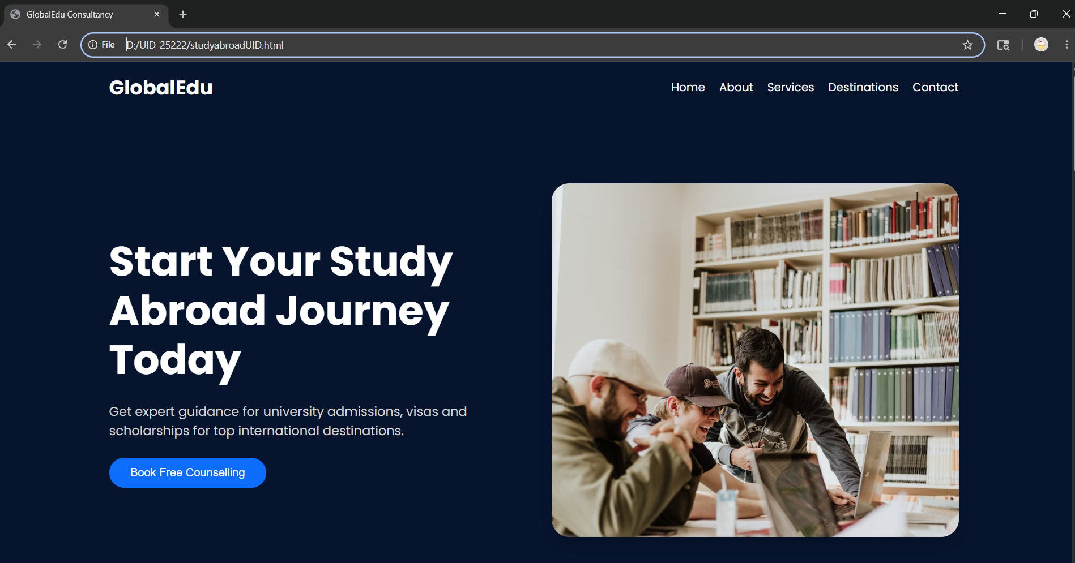
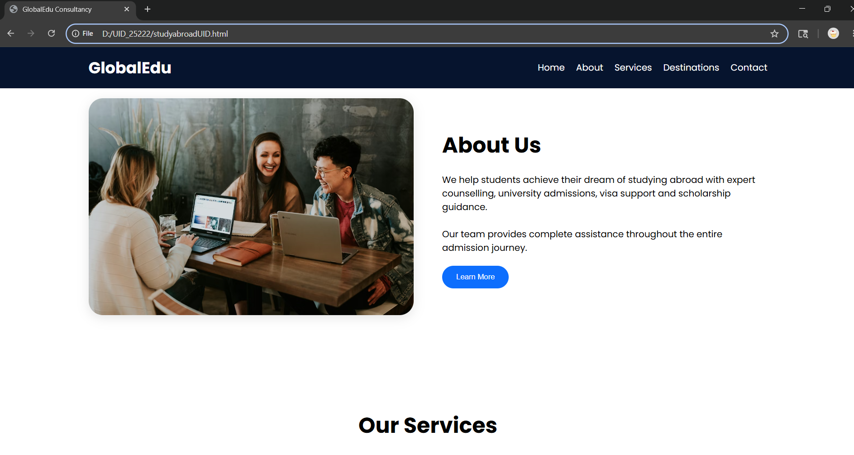
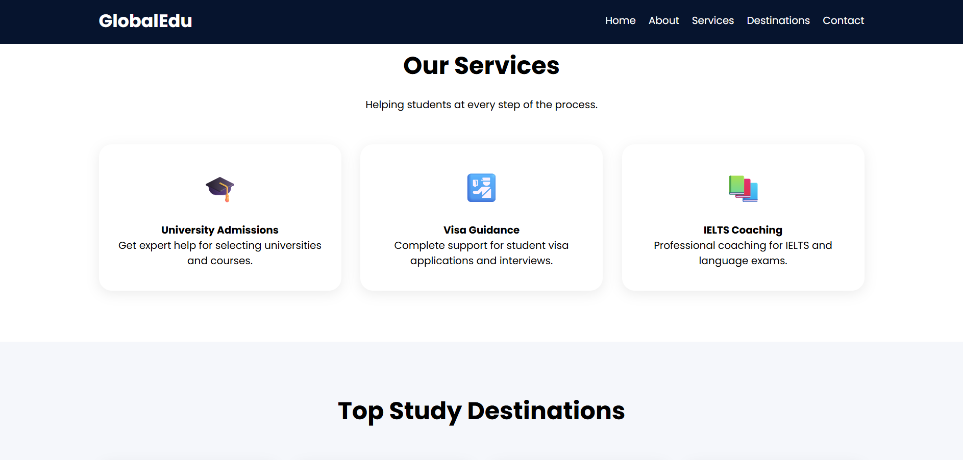
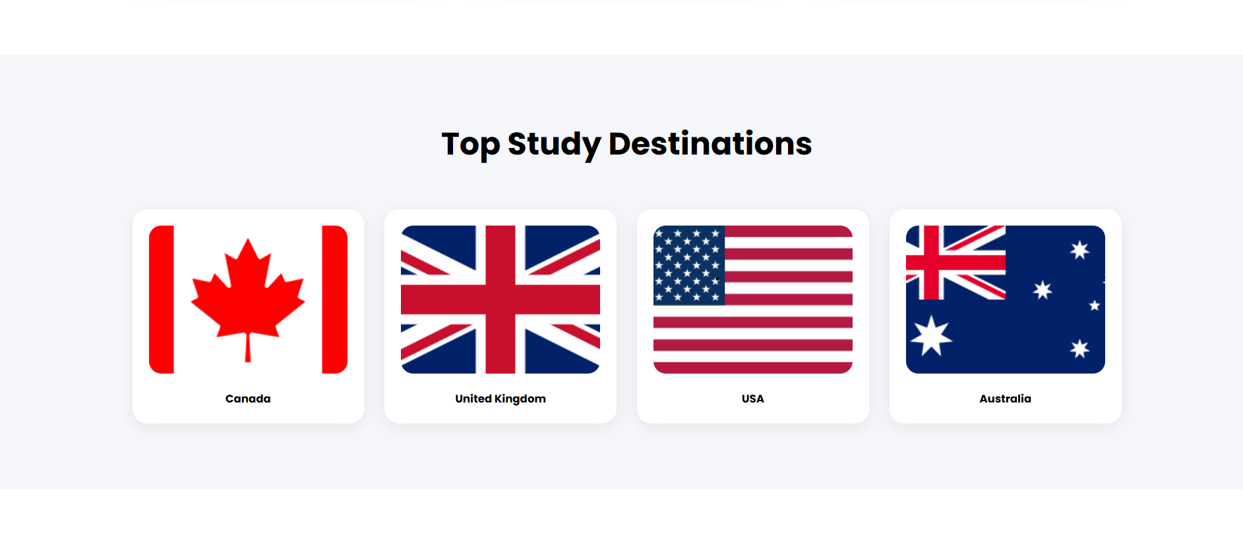
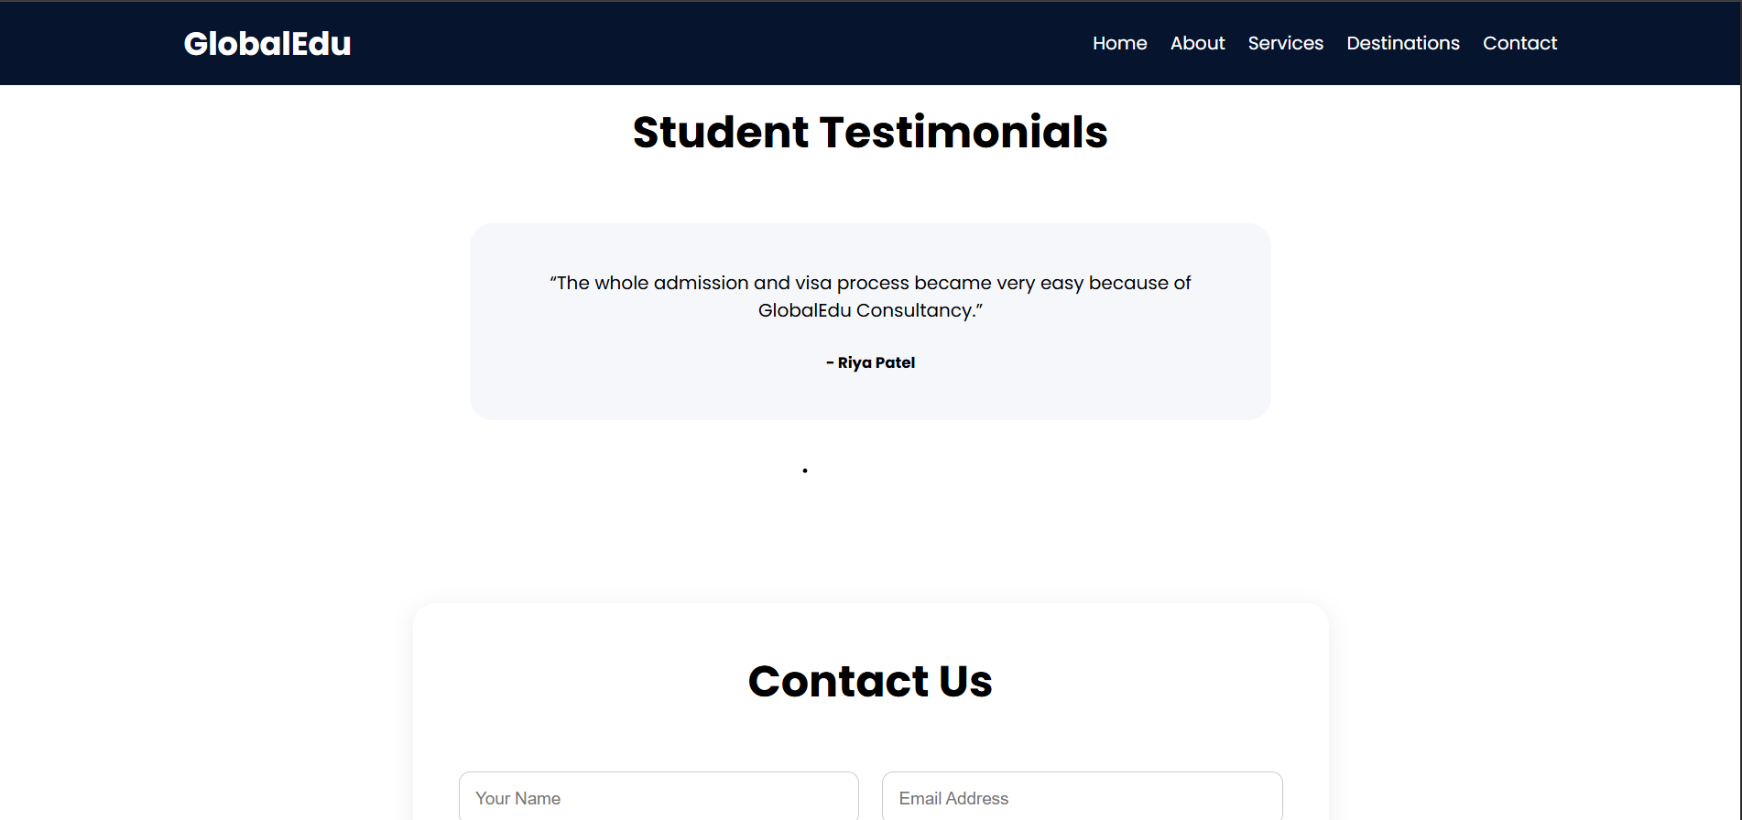

Explanation of tags –
<html> - | Root element that contains the entire web page.
<head> - | Stores metadata, title, fonts, and styling information.
<title> - | Sets the title displayed on the browser tab.
<style> - | Contains internal CSS used for designing the webpage.
<body> - | Holds all visible content displayed on the webpage.
<nav> - | Creates the navigation bar section of the website.
<div> - | A container element used to group and organize content.
<section> - | Defines different sections of the webpage such as About, Services, and Contact.
<a> - | Creates hyperlinks for navigation between sections.
<h1> - | Displays the main heading of the webpage.
<h2> - | Displays section headings.
<h4> - | Displays subheadings within cards and content areas.
<h5> - | Used for smaller headings such as testimonials and destination names.
<p> - | Displays paragraphs and descriptive text.
<img> - | Inserts images into the webpage.
<button> - | Creates clickable buttons for user interaction.
<form> - | Creates a form for collecting user information.
<input> - | Allows users to enter data such as name and email.
<textarea> - | Provides a larger text area for user messages.
<footer> - | Defines the footer section of the webpage.
<script> - | Contains JavaScript code used for webpage functionality.
<link> - | Connects external resources such as Google Fonts.

